M12550

NOVA SCOTIA ENERGY BOARD

IN THE MATTER OF: THE PUBLIC UTILITIES ACT

- and -

IN THE MATTER OF: AN APPLICATION BY NOVA SCOTIA POWER INCORPORATED To obtain a cost reasonableness review of NS Power - CI C0051815 – $5,959,515 - RTU Replacements Program – Phase 6, as outlined in Section 2.1 of the 2025 Annual Capital Expenditure Plan decision (M12012)

NON-CONFIDENTIAL INFORMATION REQUESTS

To: Nova Scotia Power Inc.
Lana Myatt
Senior Regulatory Analyst
1223 Lower Water Street
P O Box 910
Halifax, Nova Scotia B3J 3S8
By e-mail: lana.myatt@nspower.ca

From: Nova Scotia Energy Board
Board Counsel Consultants – Midgard Consulting Inc.

Responses Due: Wednesday January 7, 2026

Copies: 1 electronic copy (PDF searchable)

Contact Person: Michael Walsh
CEO
Midgard Consulting Inc.
Tel: (604) 298-4997
E-mail: mwalsh@midgard-consulting.com

Issued at Halifax, Nova Scotia, this 10th day of December 2025.

_____________________________________
Crystal Henwood, Clerk of the Board

At Page 1 of 6 of the Application CI C0051815 RTU Replacements Program – Phase 6 (Exhibit N-1), NS Power states:
This project provides for the replacement of fourteen RTUs in 2025 through 2027. The associated telecommunications equipment and the connection of Intelligent Electronic Devices (IEDs), such as recloser controllers, transformer meters, and relays, are included in this project.
- Please, for all Phase 1 RTUs:
  - Provide representative Issued for Construction (“IFC”) packages (including design basis documents, IFC drawings, and cable lists) for each RTU site. If the IFC drawings do not exist, please provide all scope documents that were used to estimate the project pricing, along with a detailed breakdown of the estimated costs and tasks.
  - Provide the corresponding as‑built station drawings for each site (RTU/SCADA/protection panels) and associated cable schedules identifying and quantifying IED and telecom connections.
  - For each Phase 1 site, summarize all variances between IFC and as‑built conditions, including design changes, field modifications, and any deviations implemented during construction.
- For all planned Phase 6 RTUs, provide representative IFC packages if available or detailed technical scope, as-built station drawings (i.e., RTU/SCADA/protection panels), and cable schedules quantifying IED/telecom connections. If the IFC drawings do not exist, please provide all scope documents that were used to estimate the project pricing, along with a detailed breakdown of the estimated costs and tasks.

At Page 2 of 6 of the Application CI C0051815 RTU Replacements Program – Phase 6 (Exhibit N-1), NS Power states:
Contingency is determined using a combination of internal subject matter expert judgment (professional engineers and project managers) and the non-binding contingency guidelines. Consistent with the maturity checklist this project is being filed as a Class 3 Estimate with a contingency value appropriate to that range.
- Please provide the methodology used to develop the Class 3 Estimate. For example, is the estimate based on historical data or NSPI’s prior RTU replacement experience?
- Please confirm if the methodology used to develop the Class 3 Estimate in this Phase different than it was for Phases 1 to 5.
  - If not, please explain any differences in methodology.
- For each of Phases 1 to 5, please provide a summary of contingency usage, including:
  - The original contingency amount and percentage of the base estimate for each phase.
  - Whether the contingency was fully used, partially used, or unused for each phase.
  - A breakdown of how contingency was applied, categorized at a minimum into: scope changes, field conditions/site constraints, compliance or documentation requirements, labour or productivity variances, and material or vendor cost variances.
- Please explain how the actual experience with contingency usage in Phases 1 to 5 has informed:
  - The contingency amount and percentage included in the Phase 6 Class 3 Estimate; and
  - Any changes to risk identification, risk allowances, and estimate methodology for Phase 6.
- For Phases 1 to 5, please describe how NS Power has tracked and observed productivity on RTU replacement work, including:
  - Any improvements in work methods, sequencing, or standardization of RTU installations.
  - Any measurable changes in labour productivity (e.g., hours per RTU, by role or by activity), and whether these represent gains, losses, or no material change over time.
- Please explain how observed productivity performance and any efficiency gains (or losses) from Phases 1 to 5 have been reflected in the Phase 6 labour-hour and cost estimates, including:
  - Whether and how historical actuals from earlier phases were used or adjusted in developing Phase 6 labour assumptions.
  - Any explicit adjustments made for evolving infrastructure complexity, compliance requirements, accessibility challenges, and broader technological scope, and how these interact with any productivity gains achieved to date.
- For Phase 6, please provide the current project risk register (or equivalent internal risk log) used at the time the Class 3 Estimate was prepared, listing for each identified risk:
  - A brief description of the risk;
  - Its assessed probability and impact (quantitative or qualitative); and
  - The principal mitigation measures assumed in the estimate.
- For the earlier RTU replacement phases (Phases 1–5), please identify any internal post-project reviews, close-out reports, or formal “lessons learned” assessments that informed the scope, cost estimate, or delivery approach for Phase 6.
- Please populate the table below, listing the estimates for the previous Phases, the actual costs, variances, and explanation of the variances.

Phase | Estimated Cost (Class 3) | Actual Cost | Variance | Explanation of Variance
Phase 1
Phase 2
Phase 3
Phase 4
Phase 5

At Page 4 of 6 of the Application CI C0051815 RTU Replacements Program – Phase 6 (Exhibit N-1), NS Power represents the following table:
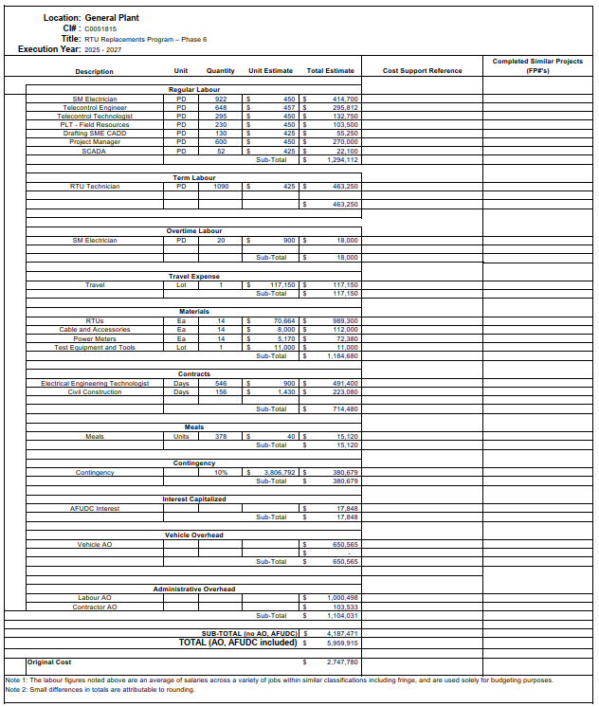
- For Phase 6 (CI C0051815) and Phase 1, please provide an itemized equipment list in Excel format, derived from the “Materials” estimate for each phase, that:
  - Identifies each piece of equipment (including, at a minimum, RTUs, power meters, communications cables, test equipment, and any associated telecommunications or networking components).
  - Shows, for each item and for each phase: description, manufacturer, model or catalog number, part number, quantity, unit of measure, unit cost, extended cost, and whether the item is new, reused, or refurbished.
  - Indicates, for each item, the pricing basis used in the estimate and, where the pricing basis is a vendor quote or agreement, identifies the vendor name and quote or agreement date. Please also provide either copies of the relevant quote or agreement pages or a comparison table showing quoted unit prices versus the unit prices used in the Phase 6 estimate, with a brief explanation of any material differences.
  - Provides either electronic copies of, or hyperlinks to, the current technical and installation manuals and data sheets for each RTU model and each associated major component (meters, IEDs, communications equipment).
- For Phase 6 (CI C0051815) and Phase 1:
  - Please explain the material cost variances between Phase 6 and Phase 1 by major cost driver (e.g., different RTU models, added cyber‑security or telecommunications equipment, different site count, or inflation/market price changes).
  - Please explain any significant labor cost variances, identifying how differences in equipment scope, site conditions, installation methodology, or commissioning/testing requirements contributed to the labor estimate changes.

At Attachment 1 of the letter filed by NS Power on December 9, 2025, NS Power presents its updated Capital Project Cost Estimate. According to the Capital Project Detailed Estimate, the total internal labour cost, including travel and meals, is CAD $1,556,044, while the Labour Administrative Overhead (AO) is CAD 735,272 (47%), which corresponds to 1,750 Person-Days (PD) for the project (125 PD per RTU).
- Please provide the components (e.g., rates and allocation basis) of the $735,272 Labour AO on 1,750 PD internal labour, including how it was calculated.
- Please provide a similar breakdown for the components of Contractor AO on 136 contractor PD, distinguishing from internal AO. Please describe the methodologies for calculating Contractor AO, Labour AO, and Vehicle AO, including, for example, the applicable cost base, the percentage or rate applied, any minimum or maximum caps, and the manner in which each overhead category differs from related direct costs.
  - Please detail how the methodologies used to calculate the Contractor AO, Labour AO or Vehicle AO in Attachment 1 of the letter filed by NS Power on December 9, 2025 differ from the methodologies used to calculate the figures provided in Application CI C0051815 RTU Replacements Program – Phase 6 (Exhibit N-1). For all differences, please explain the reason for the change.
- Please provide the loading and resulting dollar amount for each overhead category in both the original and updated estimates, including step-by-step calculations that reconcile each amount to the revised Capital Cost Detailed Estimate.

At Page 1 of 3 of the NSPI (NSUARB) IR-66 (Exhibit N-9 of 2025 ACE Plan), NS Power presents the following table:
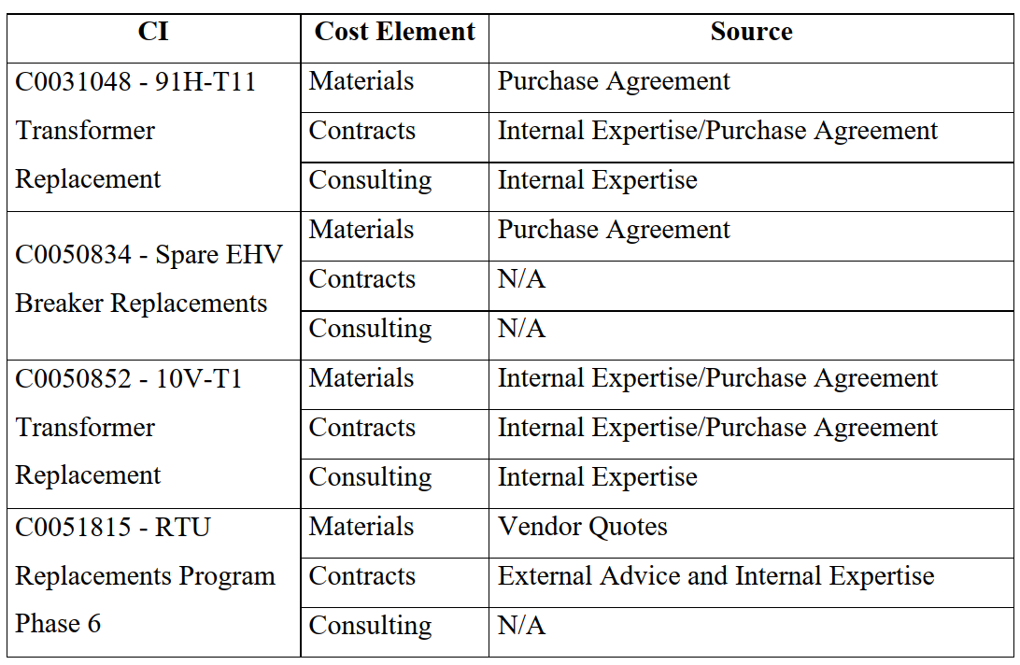
- For Phase 6 (CI C0051815) Contracts costs:
  - Please identify all external parties whose advice or services informed the Contracts cost estimate (e.g., engineering consultants, installation contractors, OEMs), and for each, provide the relevant statements of work, proposals, rate sheets, emails, or other documentation that describe their scope, rates, and assumptions.
  - Please identify the NS Power internal groups or roles whose internal expertise was used to develop the Contracts estimate.
  - Please explain how the inputs from external advice and internal expertise were translated into the final Contracts line‑item amounts (e.g., by showing estimated hours or PD, labour rates, unit rates, and any mark‑ups or contingencies applied).
- For the major RTU supply and services involved in Phase 6 (including RTUs, associated telecommunications/networking components, and installation/commissioning services), please describe the procurement strategy used (e.g., competitive tender, negotiated/sole‑source, standing offer), and for each major contract or purchase:
  - Please indicate whether the scope was competitively tendered, and if so, the number of bidders and the range of bid prices or rates received.
  - Please summarize the evaluation criteria used to select the successful vendor(s) (price, technical capability, standardization, schedule, etc.).
- With respect to the allocation of work between internal resources and external contractors for Phase 6, please describe any internal analysis NS Power has undertaken comparing the estimated cost of the chosen delivery model to alternative delivery models.
  - If such analysis exists, summarize the alternative options considered, their indicative total costs and labour hours, and the principal reasons for selecting the current delivery model for Phase 6.
  - Please provide equivalent analyses for Phases 1 to 5, comparing the estimated cost and labour hours of the delivery model used with those of any alternative delivery models, and provide the rationale for selecting the final approach.

At Page 2 of 2 of the NSPI (NSUARB) IR-140 (Exhibit N-9 of 2025 ACE Plan), NS Power states:
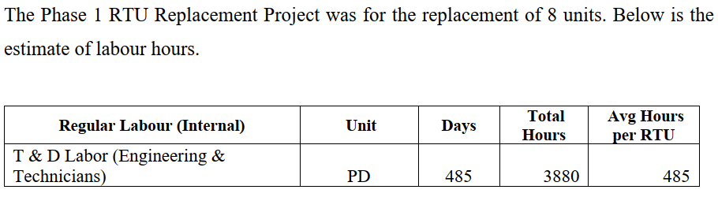
- Please populate the table below to provide the labour hours per RTU for Phase 1, consistent with the format and level of detail provided for Phase 6. If an exact allocation for Phase 1 is not available from the original estimate or records, please provide NS Power’s best estimate, explain the basis for that allocation, and identify any assumptions made.
 | Phase 1 | Phase 6
 | Total | Total
 | Average hours per RTU
SM Electrician | [enter hours] | 240
SM Electrician (overtime) | [enter hours] | 492
Telecontrol Engineer | [enter hours] | 208
Telecontrol Technologist | [enter hours] | 160
PLT-Field Resources | [enter hours] | 40
RTU Technician | [enter hours] | 200
Drafting SME CADD | [enter hours] | 360
Project Manager | [enter hours] | 64
SCADA | [enter hours] | 16
Electrical Engineering Technologist | [enter hours] | 201
Civil Construction | [enter hours] | 57
Total | 485 | 2038
- For both Phase 1 and Phase 6, please complete the table below by providing, for each role, the average hours per RTU allocated to each project phase, and the total hours per RTU. Please ensure that, for each role and phase, the Phase 1 and Phase 6 totals per RTU reconcile to the average hours per RTU previously provided in response to IR‑140.
 | Phase 6
 | Breakdown based on project phase |  |  |  |  |  | Total
 | Engineering /  design | Drafting | Installation | Test | Project management | Travel time
 | Average hours per RTU
SM Electrician | [enter hours] | [enter hours] | [enter hours] | [enter hours] | [enter hours] | [enter hours] | 240
SM Electrician (overtime) | [enter hours] | [enter hours] | [enter hours] | [enter hours] | [enter hours] | [enter hours] | 492
Telecontrol Engineer | [enter hours] | [enter hours] | [enter hours] | [enter hours] | [enter hours] | [enter hours] | 208
Telecontrol Technologist | [enter hours] | [enter hours] | [enter hours] | [enter hours] | [enter hours] | [enter hours] | 160
PLT-Field Resources | [enter hours] | [enter hours] | [enter hours] | [enter hours] | [enter hours] | [enter hours] | 40
RTU Technician | [enter hours] | [enter hours] | [enter hours] | [enter hours] | [enter hours] | [enter hours] | 200
Drafting SME CADD | [enter hours] | [enter hours] | [enter hours] | [enter hours] | [enter hours] | [enter hours] | 360
Project Manager | [enter hours] | [enter hours] | [enter hours] | [enter hours] | [enter hours] | [enter hours] | 64
SCADA | [enter hours] | [enter hours] | [enter hours] | [enter hours] | [enter hours] | [enter hours] | 16
Electrical Engineering Technologist | [enter hours] | [enter hours] | [enter hours] | [enter hours] | [enter hours] | [enter hours] | 201
Civil Construction | [enter hours] | [enter hours] | [enter hours] | [enter hours] | [enter hours] | [enter hours] | 57
Total | 0 | 0 | 0 | 0 | 0 | 0 | 2038
- For a representative Phase 6 RTU installation site, describe the planned sequence of major work steps and for each step provide the expected crew composition by job title, the typical days on site or person-days, and any assumptions regarding shift length, parallel versus sequential work, and required outages.

At Page 2 of 2 of the NSPI (NSUARB) IR-140 (Exhibit N-9 of 2025 ACE Plan), NS Power states:
The increase in estimated labour hours for Phase 6 in comparison to Phase 1 is a direct result of evolving infrastructure complexity, changes in compliance requirements, accessibility challenges, enhanced technological scope and testing procedures, and workforce constraints. These factors collectively contribute to the higher labour effort required compared to Phase 1.
- Please provide the RTU installation and commissioning test procedures used for Phase 1 and the updated test procedures to be used for Phase 6. For each, please include any relevant checklists, commissioning forms, and sign-off requirements that define the testing scope.
- Using a mark‑up, comparison table, or other clear method, highlight the material differences between the Phase 1 and Phase 6 test procedures (e.g., additional tests, added devices, additional documentation or sign‑offs), and explain how each change contributes to increased labour effort.
- Please estimate the incremental labour hours per RTU attributable to the additional Phase 6 testing and commissioning activities identified in part (b), distinguishing between engineering/design effort and field execution.

At Page 2 of 2 of the NSPI (NSUARB) IR-140 (Exhibit N-9 of 2025 ACE Plan), NS Power states:
The increase in estimated labour hours for Phase 6 in comparison to Phase 1 is a direct result of evolving infrastructure complexity, changes in compliance requirements, accessibility challenges, enhanced technological scope and testing procedures, and workforce constraints. These factors collectively contribute to the higher labour effort required compared to Phase 1.
- For each job title listed in the table below, please provide NS Power’s best estimate of the average hours per RTU in Phase 1 and Phase 6. All cells should be expressed as hours per RTU. Please ensure that, for each role and phase, the Phase 1 and Phase 6 totals per RTU reconcile to the average hours per RTU previously provided in response to IR‑140.
 | Phase 1 | Phase 6
 |  | Labour increase because of |  |  |  |  |  | Total
 |  | Infrastructure complexity | Change in compliance | Change in test procedure | Scope change | Accessibility change | Workforce constraints
 | Average hours per RTU
SM Electrician | [enter hours] | [enter hours] | [enter hours] | [enter hours] | [enter hours] | [enter hours] | [enter hours] | 240
SM Electrician (overtime) | [enter hours] | [enter hours] | [enter hours] | [enter hours] | [enter hours] | [enter hours] | [enter hours] | 492
Telecontrol Engineer | [enter hours] | [enter hours] | [enter hours] | [enter hours] | [enter hours] | [enter hours] | [enter hours] | 208
Telecontrol Technologist | [enter hours] | [enter hours] | [enter hours] | [enter hours] | [enter hours] | [enter hours] | [enter hours] | 160
PLT-Field Resources | [enter hours] | [enter hours] | [enter hours] | [enter hours] | [enter hours] | [enter hours] | [enter hours] | 40
RTU Technician | [enter hours] | [enter hours] | [enter hours] | [enter hours] | [enter hours] | [enter hours] | [enter hours] | 200
Drafting SME CADD | [enter hours] | [enter hours] | [enter hours] | [enter hours] | [enter hours] | [enter hours] | [enter hours] | 360
Project Manager | [enter hours] | [enter hours] | [enter hours] | [enter hours] | [enter hours] | [enter hours] | [enter hours] | 64
SCADA | [enter hours] | [enter hours] | [enter hours] | [enter hours] | [enter hours] | [enter hours] | [enter hours] | 16
Electrical Engineering Technologist | [enter hours] | [enter hours] | [enter hours] | [enter hours] | [enter hours] | [enter hours] | [enter hours] | 201
Civil Construction | [enter hours] | [enter hours] | [enter hours] | [enter hours] | [enter hours] | [enter hours] | [enter hours] | 57
Total | 485 | 0 | 0 | 0 | 0 | 0 | 0 | 2038

- Please provide recent site photographs that visually demonstrate “Infrastructure Complexity” and “Accessibility Change”.
  - For each such site, please explain how the observed infrastructure complexity and accessibility conditions have changed between Phase 1 and Phase 6, and how those changes are reflected in the incremental labour hours allocated to the “Infrastructure complexity” and “Accessibility change” categories in the table in part (a).

At Page 1 of 3 of the NSPI (NSEB) Undertaking U-6 (Exhibit N-21 of 2025 ACE Plan), NS Power states:
Since Phase 1, regulatory and internal standards have advanced, particularly in areas like cybersecurity, safety, and quality assurance i.e. internal documentation standards. These changes necessitate additional time and specialized expertise to meet current expectations.
- Please provide a list of the standards, guidelines, and internal procedures applicable to RTU installations in Phase 1 and in Phase 6 in the areas of cybersecurity, safety, and quality assurance, noting any updates or revisions that apply in Phase 6.
- Since Phase 1, please identify any changes in external compliance or regulatory requirements, and in internal standards, that have contributed to increased Phase 6 project management and related labour (including engineering, drafting, review, testing, and documentation). For each such change:
  - Please identify the new or revised requirement (including whether it relates to cybersecurity, safety, or quality assurance) and indicate whether it applied in Phase 1.
  - Please provide a reference to the applicable standard, guideline, or internal document.
  - Please provide NS Power’s estimate of the additional labour hours and cost attributable to the change, by affected labour category or discipline, to the extent reasonably available.

At Page 2 of 3 of the NSPI (NSEB) Undertaking U-6 (Exhibit N-21 of 2025 ACE Plan), NS Power states:
Some of the Phase 6 installations are taking place in more remote and/or physically constrained substation environments, increasing travel, setup, and execution times.
- For Phase 6, please provide the forecast travel and site setup hours and costs, and show these as a percentage of (i) total labour hours and (ii) total Phase 6 project cost.
  - Please indicate whether travel and site-setup hours and costs per RTU are materially different from those experienced in earlier RTU replacement phases, and, if so, briefly identify the principal drivers (for example, number of remote sites, typical site distances, site access constraints, or overtime requirements attributable to travel and scheduling).
- For both Phase 1 and Phase 6, please list the site locations for all RTU replacements, with the phases shown separately. For each site, please provide:
  - Location Identifiers:
    - Substation or generating station name (full location identifiers used internally).
    - If the asset is associated with multiple levels (e.g., area → zone → substation), list the complete hierarchy.
    - Municipality or nearest community.
  - Operational Access & Logistics:
    - Distance to the primary crew depot or service centre used for this work (approximate km by road, if available).
    - Please identify substations with access constraints that NS Power considers material to RTU replacement execution (e.g., limited road access, terrain challenges, seasonal restrictions, space limitations)
  - Asset-Specific Information (if a site contains more than one RTU serving distinct functions):
    - Identify the function, bay, or internal asset tag so units can be differentiated.

At Page 2 of 3 of the NSPI (NSEB) Undertaking U-6 (Exhibit N-21 of 2025 ACE Plan), NS Power states:
Also, because the installations are much broader in scope, dedicated Project Management resources are required to properly manage the overall planning, design, and implementation of the project. This broader scope involves multiple specialized roles, which increases labour hours but also enhances system resilience and operational value.
- Please detail the specific tasks, roles or scope changes in Phase 6 RTU installations that required additional Project Management hours beyond prior phases, including hour breakdowns.

At Page 2 of 3 of the NSPI (NSEB) Undertaking U-6 (Exhibit N-21 of 2025 ACE Plan), NS Power states:
Accessibility Challenges and Work Force Constraints
Some of the Phase 6 installations are taking place in more remote and/or physically constrained substation environments, increasing travel, setup, and execution times. These locational and physical challenges directly impact both the time required to reach sites and the time required for the various installation tasks compared with more accessible sites in earlier phases. The involvement of experienced System Maintenance Substation Technicians in RTU installation work is impacted by their primary focus on critical operational duties. While they remain committed to supporting capital projects, their availability is managed alongside essential system maintenance activities. As a result, their contributions to capital work, including RTU installations, are often coordinated through overtime efforts to help maintain progress without compromising core operational responsibilities.
At Page 2 of 2 of the NSPI (NSUARB) IR-140 (Exhibit N-9 of 2025 ACE Plan), NS Power also states:
Preamble: In Undertaking U‑6 (Exhibit N-21 of 2025 ACE Plan), NS Power states that accessibility challenges and workforce constraints require work to be performed on overtime to maintain progress on RTU installations. However, in the Phase 6 capital project detailed estimate, overtime is only explicitly budgeted for the SM Electrician, with an allowance of 20 person‑days for the entire project.
- Please clarify whether overtime has been assumed or budgeted for any other activities or job titles involved in the Phase 6 RTU installations.
  - If so, identify where this overtime is reflected in the Phase 6 estimate.
- For both Phase 1 and Phase 6, please complete the table below, showing for each job title the average regular hours, overtime hours, and total hours per RTU. If necessary, please include a brief footnote describing any assumptions (e.g., conversion from person-days to hours).
 | Phase 6
 | Regular | Overtime | Total
 | Average hours per RTU
SM Electrician | [enter hours] | [enter hours] | 240
SM Electrician (overtime) | 0 | 11 | 492
Telecontrol Engineer | [enter hours] | [enter hours] | 208
Telecontrol Technologist | [enter hours] | [enter hours] | 160
PLT-Field Resources | [enter hours] | [enter hours] | 40
RTU Technician | [enter hours] | [enter hours] | 200
Drafting SME CADD | [enter hours] | [enter hours] | 360
Project Manager | [enter hours] | [enter hours] | 64
SCADA | [enter hours] | [enter hours] | 16
Electrical Engineering Technologist | [enter hours] | [enter hours] | 201
Civil Construction | [enter hours] | [enter hours] | 57
Total |  |  | 2038

At Page 1 of 1 of the letter filed by NS Power on December 9, 2025, NS Power states:
Since the filing of the 2025 ACE Plan application, Nova Scotia Power Inc. (NS Power, Company) has completed some work on CI C0051815. As a result, the Company has reviewed and updated its detailed cost estimate to align more closely with its recent experience, which has resulted in an overall decrease of approximately $900,000.
- Please identify what work has been completed for each Phase 6 RTU site.
  - Please provide expected in-service dates for the 14 Phase 6 RTUs along with the project start date for each of the RTUs.
  - If any RTU sites have been fully completed, please provide in-service dates for each site and the specific scopes of work executed at those locations, along with the schedule of the completed work.
- For each completed RTU installation for Phase 6, please tabulate the actual costs by major category of NSPI’s detailed estimate, in accordance with the Descriptions provided in Attachment 1 of the letter.
- Please explain how the actual unit hours, unit labour costs, and field productivity from the completed RTU installations for Phase 6 compare with the assumptions used in the original Capital Project Detailed Estimate.
- Please describe any execution or constructability lessons learned from completed work that directly contributed to lower forecast costs for the remaining RTUs under CI C0051815.

At Attachment 1 of the letter filed by NS Power on December 9, 2025, NS Power presents its updated Capital Project Cost Estimate:
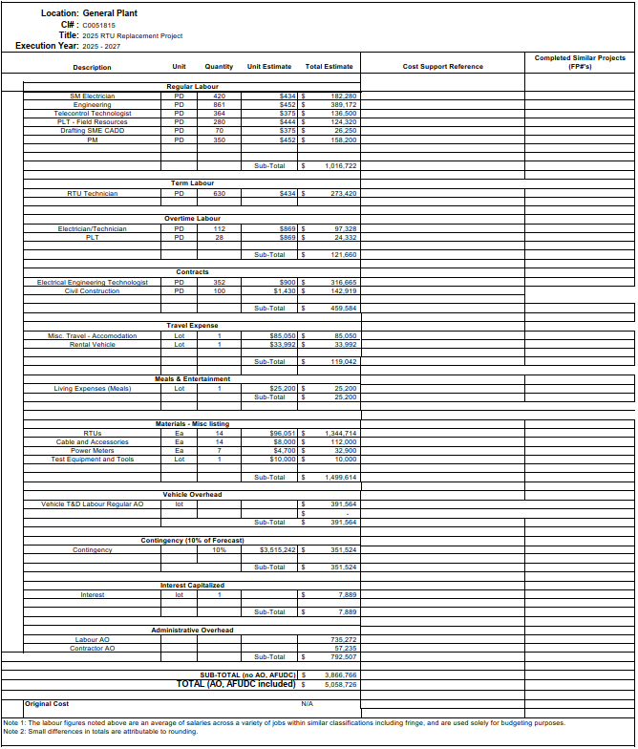
- Please provide a comparison of the original Capital Cost Detailed Estimate as filed in Exhibit N-1 versus the updated Capital Cost Detailed Estimate included in NS Power's letter dated December 9, 2025, in the form of an Excel spreadsheet.
- For each variance identified in Part (a), please explain whether the change is attributable to:
  - A change in measurement Unit (e.g., from Days to PD);
  - A change in Quantity (with quantification of the delta);
  - A change in Unit Estimate or Unit Rate (with quantification and basis for the change);
  - A scope addition or deletion;
  - A reclassification between cost categories; or
  - Other factors.
- NS Power indicates a Vehicle Overhead cost of CAD 391,564. Since the estimate already includes a separate row for travel expenses, including rental vehicles, please provide a detailed breakdown of the vehicle overhead cost and the activities to which it relates.
- Please describe how Allowance for Funds Used During Construction (AFUDC) was calculated in each Capital Cost Detailed Estimate, including the AFUDC rate or rates applied, the total capital to which AFUDC is being applied, as well as the period of time for which AFUDC is applied. Please provide the calculations in a working excel sheet.
- Please explain why the AFUDC amount has been reduced in the updated Capital Cost Detailed Estimate, identifying the relative contributions of changes in the total capitalized cost base, the timing of expenditures, and the AFUDC rate assumptions. Please provide the previous calculation alongside the current calculation within a working excel sheet.
- Please confirm whether the AFUDC amounts in both the original and updated Capital Cost Detailed Estimates reflect an expectation that capital will be tied up for only a brief period before being placed in service and included in rate base.

The sum of the total regular labour cost of $1,016,722, term labour cost of $273,420, overtime labour cost of $121,660, travel expenses of $119,042, meals of $25,200.
The labour overhead cost of $735,272 which is 47% of the sum of the total regular labour cost of $1,016,722, term labour cost of $273,420, overtime labour cost of $121,660, travel expenses of $119,042, meals of $25,200.
If the unit cost of labour is $420 per person-day (PD), then a total labour overhead costs of $735,272 corresponds to approximately 1,750 PD (calculated by dividing $735,272 labour overhead costs by $420) unit labour cost.
Calculated by dividing 1,750 PD by 14 RTUs.

